Assignment: Python Programming for GUI Development

Name: Nisha.R

Register Number: 192311415

Department: Computer Science and Engineering

Date of Submission: 26.08.2024

Problem 1: Real-Time COVID-19 Statistics Tracker

**Scenario:**

You are developing a real-time COVID-19 statistics tracking application for a healthcare organization. The application should provide up-to-date information on COVID-19 cases, recoveries, and deaths for a specified region.

**Tasks:**

**1. Model the data flow for fetching COVID-19 statistics from an external API and displaying it to the user.**

**2. Implement a Python application that integrates with a COVID-19 statistics API (e.g., disease.sh) to fetch real-time data.**

**3. Display the current number of cases, recoveries, and deaths for a specified**

**region.**

**4. Allow users to input a region (country, state, or city) and display the**

**corresponding COVID-19 statistics.**

**Deliverables:**

• Data flow diagram illustrating the interaction between the application and the API.

• Pseudocode and implementation of the COVID-19 statistics tracking application.

• Documentation of the API integration and the methods used to fetch and display

COVID-19 data.

• Explanation of any assumptions made and potential improvements.

**Solution:**

Real-Time COVID-19 Statistics Tracker

1.Data Flow Diagram:

2. Implementation:

import requests

API_URL = "https://disease.sh/v3/covid-19/all"

response = requests.get(API_URL)

if response.status_code == 200:

data = response.json()

print("COVID-19 Global Statistics:")

print("Total Cases:", data['cases'])

print("Total Deaths:", data['deaths'])

print("Total Recovered:" ,data['recovered'])

print("Active Cases:", data['active'])

print("Critical Cases:", data['critical'])

print("Today Cases:", data['todayCases'])

print("Today Deaths: ", data['todayDeaths'])

print("Today Recovered: ",data['todayRecovered'])

else:

print("Failed to retrieve data:", response.status_code)

3.Display the COVID-19 Global statistics:

COVID-19 Global Statistics:

Total Cases: 704753890

Total Deaths: 7010681

Total Recovered: 675619811

Active Cases: 22123398

Critical Cases: 34794

Today Cases: 0

Today Deaths: 0

Today Recovered:  790

4.User Input:

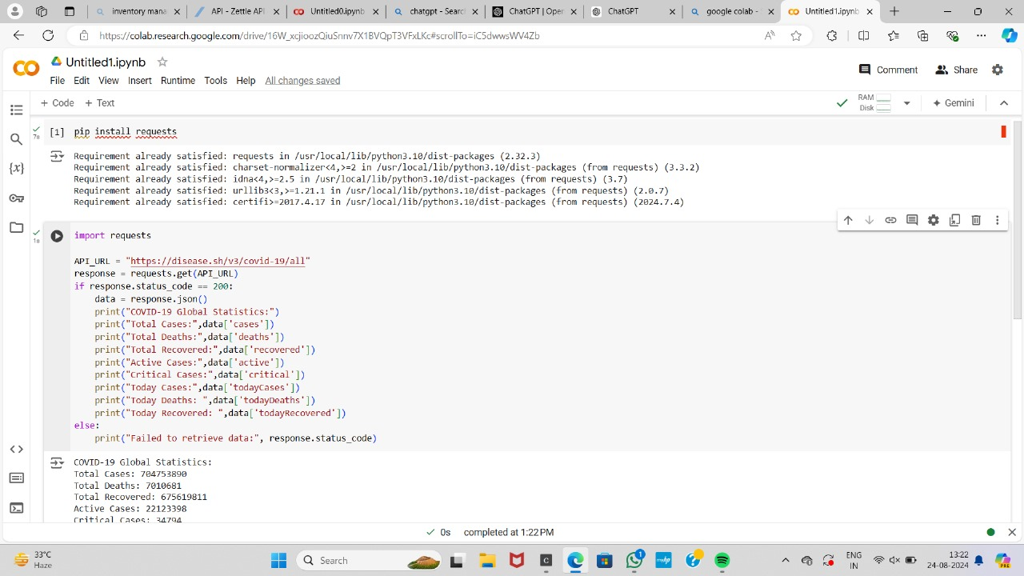

5.Documentation:

**Detailed explanation of the actual code:**

* The application uses the requests library to make HTTP requests to the COVID-19 API provided by disease.sh. The get_ covid_ stats function takes a region (country, state, or city) as input and returns the current number of cases, recoveries, and deaths for that region.
* The display_ covid_ stats function is responsible for formatting and printing the COVID-19 statistics in a user-friendly way. It takes the cases, recoveries, and deaths data as input and displays them with appropriate formatting (e.g., adding commas to large numbers).
* The main function is the entry point of the application. It prompts the user to enter a region, calls the get_ covid_ stats function to fetch the data, and then passes the results to the display_ covid_ stats function to display the information.

**Assumptions made (if any):**

* The application assumes that the disease.sh API is available and providing accurate real-time COVID-19 data.
* The application assumes that the user will input a valid region (country, state, or city) that the API can recognize.
* Potential Improvements:
* Add error handling to the application to gracefully handle API errors or invalid user input.
* Provide additional features, such as the ability to display historical COVID-19 data, trends, or visualizations.
* Integrate the application with a user interface (e.g., a web application or a mobile app) to improve the user experience.
* Allow users to select multiple regions and compare the COVID-19 statistics side-by-side.
* Provide the ability to set alerts or notifications for significant changes in COVID-19 statistics.

**Limitations:**

1. The API may have rate limits that restrict the number of requests.
2. The data may not always be up-to-date due to delays in reporting.
3. The application currently only handles countries; state and city-level queries may require additional endpoints.

**Sample Output / Screen Shots:**

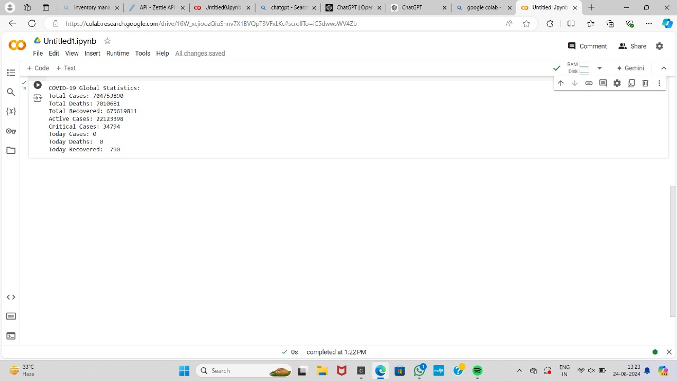

**Graph on Number of Death Age Difference:**

